AFFILIATE PLATFORM
SEO TAGS – remove all hidden links
CUSTOM LANDING PAGES – must update to use the same page as any campaign that is set to “default”. (pulls logo and or #800)
LIVE ODDS PAGE – create widget for SBO / BETOWI. Integrate UFC lines, lines should click back to sportsbook section. All sports.
WIDGETS – add ALL sports. Allow for affiliates to select sports and order. Allow for a default sport to show for when events are out of season.
CUSTOM CAMPAIGNS - create campaigns that are live and can only be viewed by the affiliate.
CUSTOM BANNER – description box or field to know who the banner belongs too
BANNER FARM - be able to “preview” which banner image is running without having to click “view” in each campaign
BANNER REPORT – be able to identify banners that are not getting traffic and remove them
NEW ARTICLE WIDGET – new design all brands
PID SEARCH - PROMO y CAMPAIGN en el marketing report y también en el nuevo PID SEARCH . Be able to clearly view who the banner ID belongs to, which campaign, etc.
MARKETING TOOLS – separate casino tools from Sportsbook tools (SBO, WW and BETOWI) When selecting Casino, only tools tagged to casino should show.
VIDEOS – add to VRB with tracking link (all brands)
HISTORY LOGS – need to know who was the last person to make edits to campaigns and what they were
MARKETING REPORT –
- in “web” field have an option for “ALL” websites integrated into 1 report
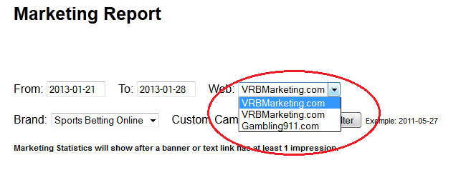
- edit PROMO & CAMPAIGN columns in report to show what kind of tool was used. Ie. Text link. Same should apply to new PID search tool.

